Appendix

Yihang Zhao, Yixuan Yang, Lourdes Siman

**Overview of Mexican Market**

Mexico is growing in the agri-tech industry. It holds the 2nd biggest growth rate only second to Brazil. The chart below shows the precision agriculture market in Mexico compared to that of Brazil.

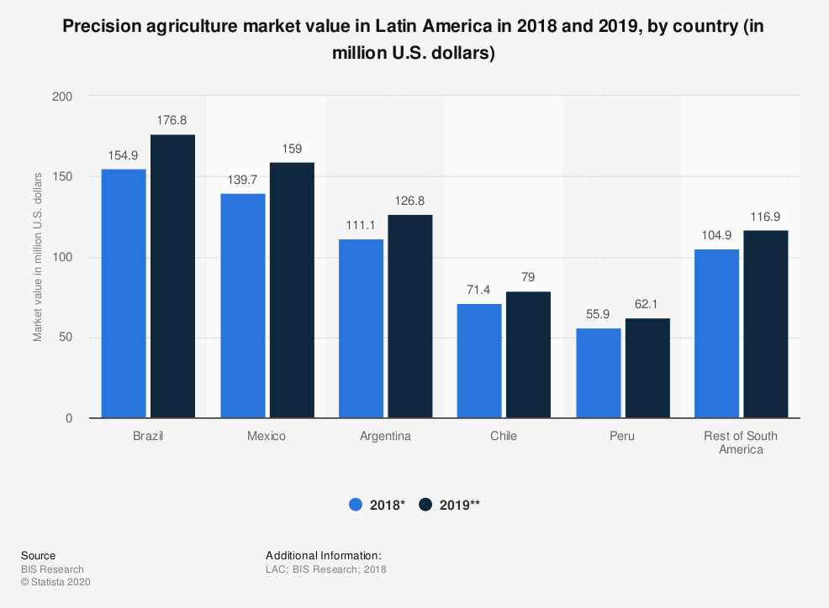

It is also important to note that Mexico’s closeness to the US is a variable of high value. Post-pandemic world has reduced advances in globalization. The shipping and freight industry have been severely impacted and we expect to see a slow to moderate recovery. For this reason, closeness and accessibility plays a key role when entering a new market in our post-pandemic world.

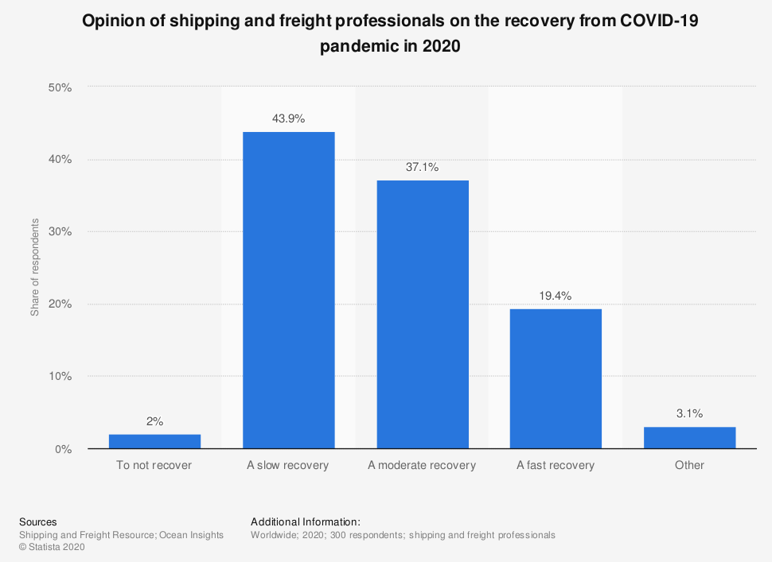

Post-pandemic Mexico also finds itself yearning for more technology. The following graph shows how information technology spending positively changed from 2020 to 2021 in order to adapt and be able to increase yield.

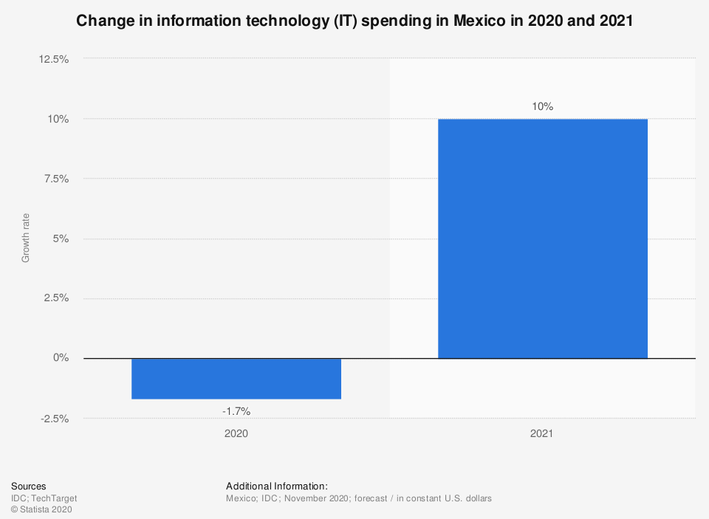

Lastly, out of Latin America, Mexico holds the second place on ease of doing business slightly behind Chile (2019) which can be evidenced below.

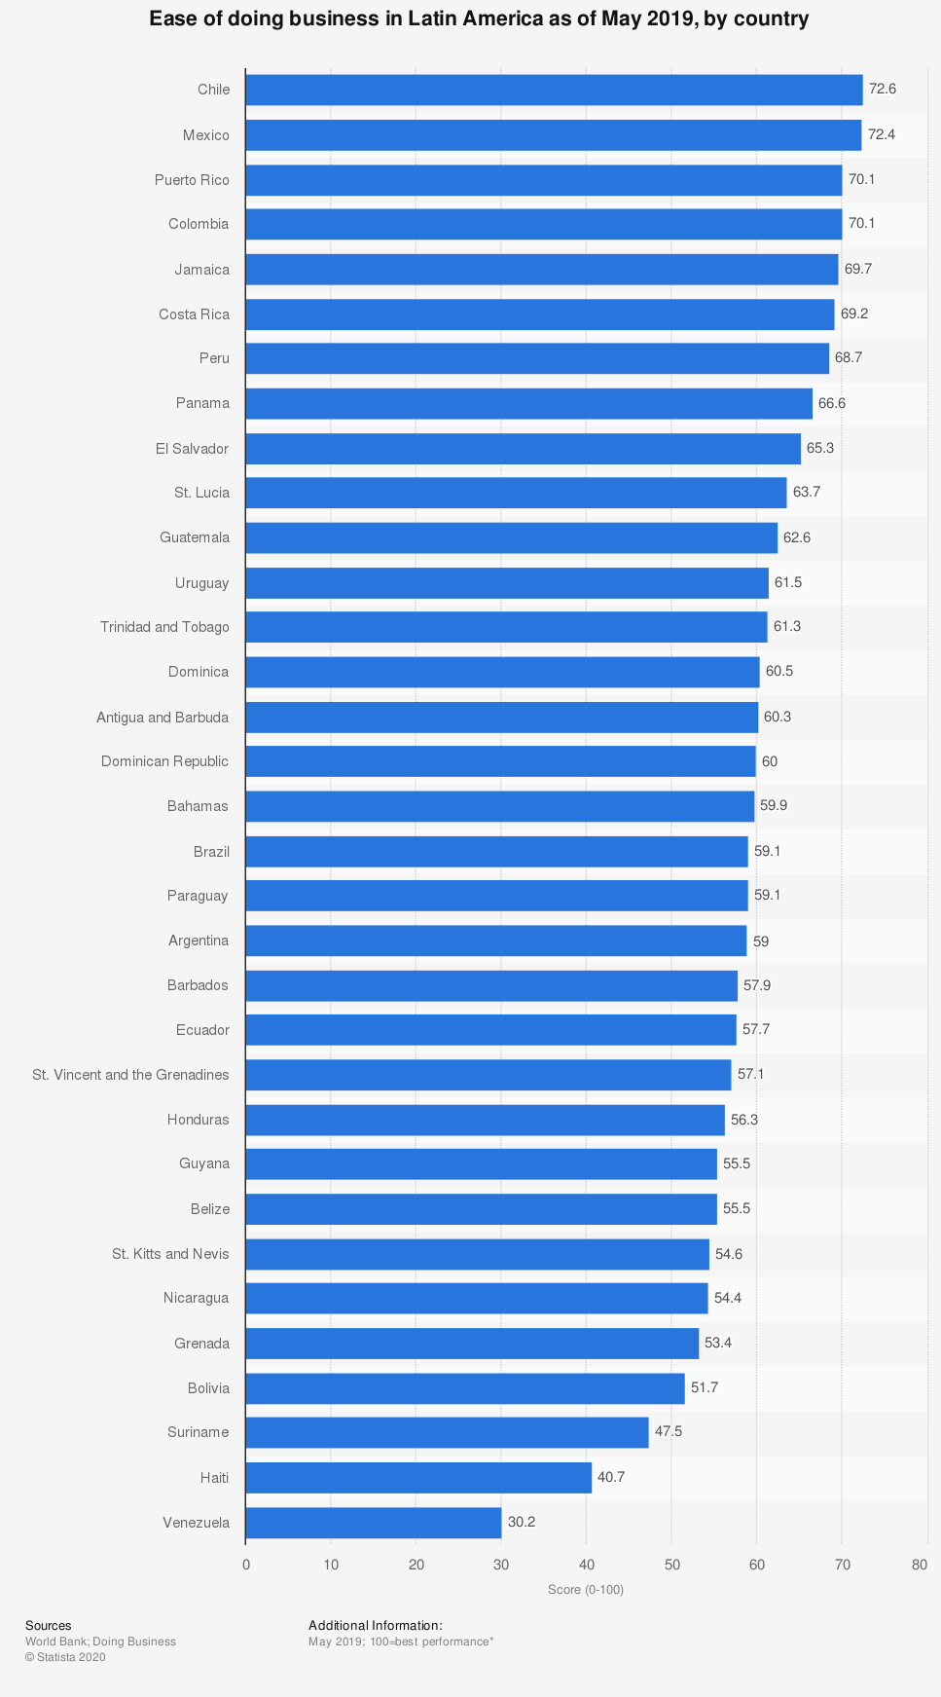

**External Environment**

* multinationals are already growing their crops in Mexico; for example, PepsiCo’s Frito lay grows its potatoes in Mexico.
* Mexico was forecast to register a relatively high compound annual growth rate of the precision agriculture, amounting to 16.1 Percent.

<https://www-statista-com.proxygw.wrlc.org/statistics/1184401/latin-america-precision-agriculture-cagr-country/>

* Mexico is considered a priority market for the US agriculture machinery industry. Agricultural equipment exports from the US to Mexico in 2019 totaled 1.6 billion USD which is 69% of market share. https://www.trade.gov/knowledge-product/mexico-c-agribusiness
* Between 2020 and 2022, the government intended to invest 118.05 billion Mexican pesos in telecommunication infrastructure. https://www-statista-com.proxygw.wrlc.org/statistics/1114877/mexico-government-investment-telecommunication-infrastructure/

**Competitive advantage**

* “According to a survey carried out among 52 enterprises in the country (Mexico), around 29 percent of respondents mentioned this incentive. Savings on supplies input was the second most commonly used incentive, by 18 percentrespondents.”(<https://www-statista-com.proxygw.wrlc.org/statistics/1184343/mexico-incentives-agricultural-technology-adoption/>). As a precision technology, GAAP would be great to satisfy clients’ top requirements in demand.
* The much lower price point for the flight system plus our GAAP package should open up a lot of possibilities in Mexico.
* In sum, almost 90% of all farms have an area of 20 hectares or less. At the other end of the size spectrum, 2.2% of farms were larger than 100 hectares. All the states along the US border have average farm size in excess of 100 hectares. At the other extreme, a ring of states in central Mexico have average farm sizes that are below 5 hectares (<https://geo-mexico.com/?p=11019>).
* Precision agriculture is not for big agriculture properties only, studies have demonstrated that by using precision agricultural techniques, the increase in yields remain proportionate between large and small plots of land (<http://www.emtoscipublisher.com/index.php/ijh/article/html/3086/>).
* Pricing of Pix4D (<https://www.pix4d.com/pricing/pix4dfields>)

**Risks & Possible strategy plan**

* SGS is also a strong competitor for us because it entered into Mexico earlier and it has a mature precision agriculture platform and professional labor force. Its service ranges from soil chemical mapping to drainage evaluation. They do not only provide software and they also have their own consultants who can provide analytics services. (<https://www.sgs.mx/en/agriculture-food/seed-and-crop/soil-leaf-and-water-services/precision-farming>)
* Mexico’s national price level is 0.6 which means the people can spend 0.6 US dollars to buy stuff in Mexico but have to pay 1 US dollar for the same product in the US. However, the exchange rate puts Mexican people in a negative position because the peso devalued which results in their purchasing power weakening. For the investors, it’s also good news because it means for the US investors, the US dollar appreciates. The investment cost in Mexico market will decrease.
* In terms of customer service, a commitment to data security is very important. The customers may really care about their data and they don’t want their data to be disclosed or stolen by the competitors. So if the company can care about this field, it can also increase the company’s reputation and popularity and then further increase the sales.
* Because we may focus on the smallholder farmers rather than only focus on the big company, our pricing can be affordable. They can also use technology to manage their own crops. Products can be divided into different categories and have different prices.